**Orders from Cerner to Orchestrate**

**Version 1.7**

**Prepared By: Rich Allison**

**Date: 8/12/2019**

Document Control 3

Resources 3

Project Distribution List 3

Document Version Control 3

1. Introduction 4

1.1 Purpose 4

1.2 Project Scope 4

1.3 Terminology Standards 4

1.3.1 Acronyms 4

1.3.2 Glossary 4

1.4 Document References 4

*2.* Diagram 5

3. Requirements 6

3.1 Functional Requirements 6

3.2 Non-Functional Requirements 7

3.3 Messaging Protocols 8

3.3.1 Inbound to the BayCare Cloverleaf from Cerner 8

3.3.2 Outbound to the BayCare Cloverleaf 8

3.3.3 Inbound to the Vendor 8

3.3.4 Outbound to Orchestrate from BayCare’s Cloverleaf 8

4. HL7 Messaging 9

4.1 Messaging Format 9

4.1.1 Segments 9

4.1*.*2 Messaging Event Types 9

4.1*.*3 Cloverleaf Configuration Files 9

4.1.4 Cloverleaf Site Location 10

4.2 Data Transformation Requirements 10

4.3 Sample Message 13

Appendix A: Risks and Concerns 14

Appendix B: Issues List 14

# **Document Control**

## Resources

|  |  |  |
| --- | --- | --- |
| **Name** | **Role** | **Email** |
| Nydia Anders | IS Project Manager | Nydia.anders@baycare.org |
| Rich Allison | Enterprise Integration Analyst, Sr | Rich.allison@baycare.org |
| Rod Stephens | Teletracking Systems Analyst | Rod.Stephens@baycare.org |
| Terri Norton | Teletracking Systems Analyst Sr. | Terri.norton@baycare.org |
| Tony McArtor | Enterprise Integration Analyst, Sr | Tony.mcartor@baycare.org |
| Donald Golden | IS Manager Clinical Systems | Donald.golden@baycare.org |
| Kim Bell | IS Supervisor Clinical Systems | Kim.bell@baycare.org |
| Amelia Malick | Teletracking Vendor | Amelia-malick@teletracking.com |
| Nate Gilkerson | Teletracking Vendor | Nate-gilkerson@teletracking.com |
| Andrew Skvarca | Teletracking Vendor | Andrew-skvarca@teletracking.com |
| Sarah Thies | Enterprise Integration Analyst | Sarah.Thies@baycare.org |

## Project Distribution List

## Document Version Control

|  |  |  |  |
| --- | --- | --- | --- |
| **Version** | **Date** | **Modifier** | **Description** |
| V1.0 | 6/24/2016 | Lois Whitley | Originally Created |
| V1.1 | 6/28/2016 | Rich Allison | Added Cloverleaf info |
| V1.2 | 3/1/2017 | Sarah | Updated FSI |
| V1.3 | 3/2/2017 | Rich Allison | Updated Cloverleaf |
| V1.4 | 8/22/2018 | Rich Allison | Updated Cloverleaf |
| V1.5 | 11/5/2018 | Rich Allison | Updated Cloverleaf |
| V1.6 | 3/13/19 | Rich Allison | Updated Cloverleaf |
| V1.7 | 8/12/19 | Tiffany Bohall | Updated Cloverleaf |
|  |  |  |  |

# 1. Introduction

## 1.1 Purpose

The purpose of this document is to outline the Orders interface requirements for the Orchestrate Teletracking application.

## 1.2 Project Scope

Integration for this application includes a Scheduling interface (SIU) from Soarian to Orchestrate, Orders Interface (ORM) from Cerner and an Orders interface from the RIS to Orchestrate. The project includes only a handful of modalities, which are listed below in section 3.1 Functional Requirements.

Additionally, there are two sources of patient information: Soarian Scheduling for outpatients and Cerner Orders for Inpatients and Emergency Room Visits.

## 1.3 Terminology Standards

### 1.3.1 Acronyms

**ORM –** General order message used to transmit information about an order; request for service sent between applications, or in some cases within a single application.

**ORM-O01** - only type of order message; trigger events involve changes to an order such as new orders, cancellations, information updates, discontinuation, etc.

**ORR –**Order response; when Soarian scheduling sends an SIU (schedule) transaction to GE Centricity Imaging RIS-IC, an order is created and automatically sent to Cerner. Cerner sends back an ORR transaction from the original order, as an order response with its order number.

### 1.3.2 Glossary

**TeleTrack** is the vendor name.

**Orchestrate** is the application.

## 1.4 Document References

Orchestrate HL7 Interface Specifications

# *2.* Diagram

Provide a solution diagram that depicts the integration of components specified in this IDBB. This diagram must include the data flow for the interfaces (source and target).

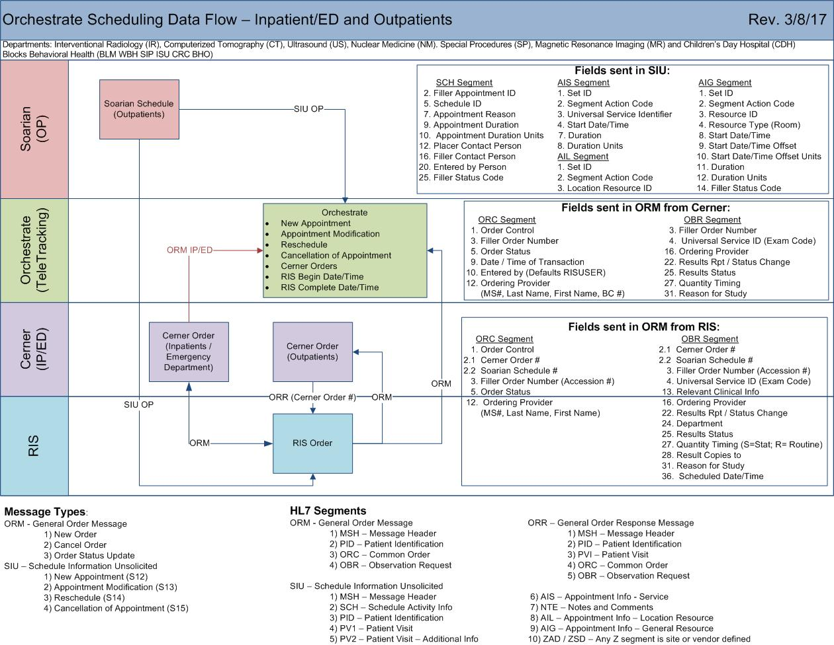

# 3. Requirements

## 3.1 Functional Requirements

Provide detail for the below functional requirements. The message transformation requirements for the components defined in this specification should be specified in section 4.2 of this document.

|  |  |  |
| --- | --- | --- |
| **CLOVERLEAF** |  |  |
| **Number** | **Requirement Name** | **Requirement Description** |
| FR.2019.8.1 | Cerner radiology orders route passing messages over to Orchestrate from the Imaging site in Cloverleaf | Radiology orders are needed from Cerner to accommodate inpatient and emergency class patients. |
| FR.2016.1.0 | Department Filter: pulled from OBR.24 | This Cerner Department filter is now filtered in Cloverleaf  BD –Bone Density  BN - not defined for Radiology  CDH – Children’s Day Hospital  CT – Computerized Tomography  DX –Diagnostic Imaging  EC –Echo Cardiology  IR – Interventional Radiology  MR – Magnetic Resonance Imaging  NM - Nuclear Medicine  SP – Special Procedures  US – Ultrasound  WM –Women’s Imaging |
| FR.2019.8.2 | Suppress locations: pulled from MSH.4 | BLM, WBH, SIP, ISU, CRC, BHO |
|  |  |  |
| FR.2019.8.4 | Suppress rebound messages that are class O with no location | PV1.2 =O, PV1.3.1 and PV1.3.2 =null and ORC.18=Rebound, suppress the transaction |

## 3.2 Non-Functional Requirements

Provide concise detail for the below non-functional requirements. The below requirements must be evaluated for every project.

|  |  |  |
| --- | --- | --- |
| **Cloverleaf** |  |  |
| **Number** | **Requirement Name** | **Requirement Description** |
| NFR.2019.8.5 | 2nd orders interface is sending Cerner radiology orders directly to Orchestrate (no imaging pass through) | Radiology orders are needed from Cerner to accommodate inpatient and emergency class patients. |
| NFR.2019.8.6 | Department Filter: pulled from OBR.24 | This Cerner Department filter is now filtered in Cloverleaf  BD –Bone Density  BN –not defined for Radiology  CDH – Children’s Day Hospital  CT – Computerized Tomography  DX - Diagnostic Imaging  EC – Echo Cardiology  IR – Interventional Radiology  MR – Magnetic Resonance Imaging  NM - Nuclear Medicine  SP – Special Procedures  US – Ultrasound  WM –Women’s Imaging |
| NFR.2019.8.7 | Suppress locations: pulled from MSH.4 | BLM, WBH, SIP, ISU, CRC, BHO |

## 3.3 Messaging Protocols

Below are listed the details for the messaging protocols that will be leveraged for this integration. Please see the reference document located on the Integration SharePoint server: <insert link to document here>

### 3.3.1 Inbound to the BayCare Cloverleaf from Cerner

* TCP IP

### 3.3.2 Outbound to the BayCare Cloverleaf

* Click here to enter text.

### 3.3.3 Inbound to the Vendor

* Click here to enter text.

### 3.3.4 Outbound to Orchestrate from BayCare’s Cloverleaf

* TCP IP

# 4. HL7 Messaging

## 4.1 Messaging Format

### 4.1.1 Segments

The segments utilized for this interface are:

MSH

PID

PV1

ORC

OBR

*Message Construction Notes:*

*[Square Brackets] – Optional*

*{Curly Brackets} – Repeatable*

*MSH – Message Header*

*PID – Patient ID Segment*

*PV1 – Patient Visit Segment*

*PV2 – Patient Visit – Additional Info Segment*

*IN1 – Insurance Segment*

*IN2 – Insurance – Additional Info Segment*

*ORC – Common Order Segment*

*OBR – Observation Request Segment*

*OBX – Observation/Result Segment*

### 4.1*.*2 Messaging Event Types

Below are the messages types necessary for this integration

|  |  |
| --- | --- |
| **Event Type** | **Description** |
| ORM^O01 | Order message |
| ORR^O02 | Order response |
|  |  |
|  |  |

### 4.1*.*3 Cloverleaf Configuration Files

For each HL7 interface specified in Section 2 of this document, identify the Cloverleaf Configuration Files: Variants, TCL Scripts, Xlates, Filters, etc.

**Variants**: HL7 2.3/cerner_emr ORM_O01

**TCL Scripts**: None

**Xlates** (both orders routes are using single translate): cerner_teletrac_orch_orm.xlt

### 4.1.4 Cloverleaf Site Location

There is an inbound Cerner Orders connection on the teletrck_24 site.

## 4.2 Data Transformation Requirements

| **Field Description** | **HL7 Field Loc.** | **Required Y/N** | **Data Type** | **Length** | **Notes** |
| --- | --- | --- | --- | --- | --- |
| Message Header | MSH |  |  |  | MSH |
| Message Segment Field Separator | MSH.1 |  |  |  |  |
| Encoding Characters | MSH.2 |  |  |  |  |
| Sending Application | MSH.3 |  |  |  | HNAM |
| Sending Facility | MSH.4 |  |  |  | BAYCARE |
| Receiving Application | MSH.5 |  |  |  | Orchestrate |
| Receiving Facility | MSH.6 |  |  |  | Put the facility into MSH.6 of outbound message |
| Date/Time of Message | MSH.7 |  |  |  | YYYYMMDDHHMM |
| Message Type | MSH.9 |  |  |  | If MSH.9 = ORR, hard code ORM in subfield 0 and O01 in subfield 1. (i.e. ORM^O01) |
| Message Control ID | MSH.10 |  |  |  |  |
| Processing ID | MSH.11 |  |  |  | P |
| Version ID | MSH.12 |  |  |  | 2.3 |
| Character Set | MSH.18 |  |  |  |  |
| Patient Identification Segment | PID |  |  |  | PID |
| Patient Internal ID | PID.2 |  |  |  | Medical Record Number |
| Patient Identifier List | PID.3 |  |  |  | CPI |
| Patient Name | PID.5 |  |  |  | Components: <family name>^<given name>^  Displayed in Orchestrate as Patient First name and Patient Last Name |
| Birth Date | PID.7 |  |  |  | YYYYMMDD |
| Gender | PID.8 |  |  |  | Patient’s Sex |
| Race | PID.10 |  |  |  |  |
| Patient Account Number | PID.18 |  |  |  | Used in Orchestrate to uniquely identify a patient internally |
| Patient Visit Segment | PV1 |  |  |  |  |
| Patient Class | PV1.2 |  |  |  | Patient Status/Type:  I – Inpatient  O - Outpatient  E - Emergency |
| Assigned Patient Location | PV1.3 |  |  |  | Components:<Point of Care>^<room>^<bed>^<facility>^<building>^<floor> |
| Admission Type | PV1.4 |  |  |  |  |
| Attending Doctor | PV1.7 |  |  |  |  |
| Hospital Service | PV1.10 |  |  |  |  |
| Admit Source | PV1.14 |  |  |  |  |
| Admitting Doctor | PV1.17 |  |  |  |  |
| Servicing Facility | PV1.39 |  |  |  |  |
| Admit Date / Time | PV1.44 |  |  |  |  |
| Common Order Segment | ORC |  |  |  |  |
| Order Control | ORC.1 |  |  |  | Change “NA” to “NW” |
| Placer Order Number | ORC.2 |  |  |  |  |
| Order Status | ORC.5 |  |  |  | If ORC.5 =IX, hard code 20 outbound |
| Quantity Timing | ORC.7 |  |  |  | Application as Procedure Start Time, copy from OBR.27 |
| Date / Time of Transaction | ORC.9 |  |  |  |  |
| Entered By | ORC.10 |  |  |  | Search for “BayCare Dr Number”, if found, copy subfields 0, 1, 2 and 3 outbound (i.e. ID^last name^ first name^middle) |
| Ordering Provider | ORC.12 |  |  |  | Search for “BayCare Dr Number”, if found, copy subfields 0, 1, 2 and 3 outbound (i.e. ID^last name^ first name^middle) |
| Enterer’s Location | ORC.13 |  |  |  |  |
| Order Effective Date / Time | ORC.15 |  |  |  |  |
| Entering Device | ORC.18 |  |  |  |  |
| Action By | ORC.19 |  |  |  | Search for “BayCare Dr Number”, if found, copy subfields 0, 1, 2 and 3 outbound (i.e. ID^last name^ first name^middle) |
| Observation Request Segment | OBR |  |  |  |  |
| Universal Service ID | OBR.4 |  |  |  | Text – Procedure Location  Commented out Cerner code to remove ImageCast EKG’s OBR.4 |
| Results Report Status Change Date / Time | OBR.22 |  |  |  |  |
| Diagnostic Service Section ID | OBR.24 |  |  |  |  |
| Quantity timing | OBR.27 |  |  |  |  |
| Reason for Study | OBR.31 |  |  |  | Procedure Description |

## 4.3 Sample Message

**Inbound from Cerner (through the imaging site) to teletrck_24**

MSH|^~\&|HNAM|CERNER|MPH|BAYCARE|20190725140657||ORM^O01|Q4432210264T5825940421||2.3||||||8859/1

PID|1|7000111662^^^BayCare MRN^MRN^SOARIAN|7000111662^^^BayCare MRN^MRN^SOARIAN~810123738^^^BayCare CMRN^Community Medical Record Number^SOARIAN||Orchestrate^Mpinpatienttwo^^^^^Current||19701004|M||W|45 testing^^New Port Richey^FL^34654^^Home||(789)789-8978^PRN||GER|M|AME|6000145027^^^BayCare FIN^FIN NBR^SOARIAN||||NOH|||0

PV1|1|I|BAR6^0679^02^MPH^^Bed(s)^MPH|R|||MS006716^Beattie^Martin^C^^^^^BayCare Dr Number|||MED||||RP|||MS006716^Beattie^Martin^C^^^^^BayCare Dr Number|I||8|||||||||||||||||||MPH||Active|||20190725124500

PV2||Acute|^abdominal pain|||||||0||||||||||||CONFID|^^589743

ORC|CA|15247813781^HNAM_ORDERID|29005815^Imagecast Order Number||85||||20190725140655|RISUSER^MUBUWEU^PSDLWUUSK^^^^^^BayCare Dr Number^Personnel^^^ORGANIZATION DOCTOR^CD:114979916||MS006716^Beattie^Martin^C^^^^^BayCare Dr Number|||20190725140654|||REBOUND^ESI Default|RISUSER^MUBUWEU^PSDLWUUSK^^^^^^BayCare Dr Number^Personnel^^^ORGANIZATION DOCTOR^CD:114979916

OBR|1|15247813781^HNAM_ORDERID|29005815^Imagecast Order Number|CCHEST1^CT Chest w/ Con||||||||||||MS006716^Beattie^Martin^C^^^^^BayCare Dr Number||||||20190725140655||CT|||1^^0^20190725130000^^Routine|||ST|^Chest Pain

OBX|1|ID|Pregnant^Pregnant||N

OBX|2|IS|CD:2952348151^Iodine Allergy.||N

**Outbound to Orchestrate**

MSH|^~\&|HNAM|BAYCARE|Orchestrate|MPH|20190725140657||ORM^O01|Q4432210264T5825940421|P|2.3||||||8859/1

PID||7000111662|810123738||Orchestrate^Mpinpatienttwo||19701004|M||W||||||||6000145027

PV1||I|BAR6^0679^02^MPH^^Bed(s)^MPH|R|||MS006716^Beattie^Martin^C|||MED||||RP|||MS006716^Beattie^Martin^C||||||||||||||||||||||MPH|||||20190725124500

ORC|CA|15247813781|||85||1^^0^20190725130000^^Routine||20190725140655|RISUSER^MUBUWEU^PSDLWUUSK||MS006716^Beattie^Martin^C|||20190725140654|||REBOUND|RISUSER^MUBUWEU^PSDLWUUSK

OBR||||CCHEST1^CT Chest w/ Con||||||||||||||||||20190725140655||CT|||1^^0^20190725130000^^Routine||||Chest Pain

**Inbound from Cerner**

MSH|^~\&|HNAM|CERNER|MPH|BAYCARE|20190725130043||ORM^O01|Q4432210072T5825940130||2.3||||||8859/1

PID|1|7000111662^^^BayCare MRN^MRN^SOARIAN|7000111662^^^BayCare MRN^MRN^SOARIAN~810123738^^^BayCare CMRN^Community Medical Record Number^SOARIAN||Orchestrate^Mpinpatienttwo^^^^^Current||19701004|M||W|45 testing^^New Port Richey^FL^34654^^Home||(789)789-8978^PRN||GER|M|AME|6000145027^^^BayCare FIN^FIN NBR^SOARIAN||||NOH|||0

PV1|1|I|BAR6^0679^02^MPH^^Bed(s)^MPH|R|||MS006716^Beattie^Martin^C^^^^^BayCare Dr Number|||MED||||RP|||MS006716^Beattie^Martin^C^^^^^BayCare Dr Number|I||8|||||||||||||||||||MPH||Active|||20190725124500

PV2||Acute|^abdominal pain|||||||0||||||||||||CONFID|^^589743

ORC|NW|15247813781^HNAM_ORDERID|||20||||20190725130027|DSS48590^Swetnich^Donna^S^^^^^Username^Personnel^^^Username||MS006716^Beattie^Martin^C^^^^^BayCare Dr Number|||20190725130042|||Written^Written/Paper/Fax|DSS48590^Swetnich^Donna^S^^^^^Username^Personnel^^^Username

OBR|1|15247813781^HNAM_ORDERID||CCHEST1^CT Chest w/ Con||||||||||||MS006716^Beattie^Martin^C^^^^^BayCare Dr Number||||||20190725130042||CT|||1^^0^20190725130000^^Routine|||ST|^Chest Pain

OBX|1|ID|Pregnant^Pregnant||N

OBX|2|IS|CD:2952348151^Iodine Allergy.||N

**Outbound to Orchestrate**

MSH|^~\&|HNAM|BAYCARE|Orchestrate|MPH|20190725130043||ORM^O01|Q4432210072T5825940130|P|2.3||||||8859/1

PID||7000111662|810123738||Orchestrate^Mpinpatienttwo||19701004|M||W||||||||6000145027

PV1||I|BAR6^0679^02^MPH^^Bed(s)^MPH|R|||MS006716^Beattie^Martin^C|||MED||||RP|||MS006716^Beattie^Martin^C||||||||||||||||||||||MPH|||||20190725124500

ORC|NW|15247813781|||20||1^^0^20190725130000^^Routine||20190725130027|DSS48590^Swetnich^Donna||MS006716^Beattie^Martin^C|||20190725130042|||Written|DSS48590^Swetnich^Donna

OBR||||CCHEST1^CT Chest w/ Con||||||||||||||||||20190725130042||CT|||1^^0^20190725130000^^Routine||||Chest Pain

5. Alerts

Are you going to need alerting on this connection?

|  |  |
| --- | --- |
| Yes |  |
| No |  |

If the answer is yes, please complete the table below:

|  |  |  |  |
| --- | --- | --- | --- |
| **Site Name** | **Hours of Support** | **Distribution Group** | **Comments** |
|  |  |  |  |
| teletrck_24 | 24/7 | IS Ancillary Applications Team | Alert for outbound queue depth > 100 |

# Appendix A: Risks and Concerns

|  |  |  |  |  |  |  |  |  |
| --- | --- | --- | --- | --- | --- | --- | --- | --- |
| **Project Name** |  |  | | |  |  |  |  |
| **Number** | **Risk / Concern** | **Comment** | **Mitigation** | | |  |  |  |
| RC.2013.1.0 |  |  | |  | |  |  |  |

# Appendix B: Issues List

This is a dynamic list of the open issues related to the IDBB that remain to be solved, including but not limited to TBDs, pending decisions, information needed, conflict awaiting resolution, and the like.

|  |  |  |  |  |  |  |  |  |
| --- | --- | --- | --- | --- | --- | --- | --- | --- |
| **Project Name** |  |  | | |  |  |  |  |
| **Number** | **Issue** | **Comment** | **Fix** | | |  |  |  |
| I.2013.1.0 |  |  | |  | |  |  |  |

* End of document